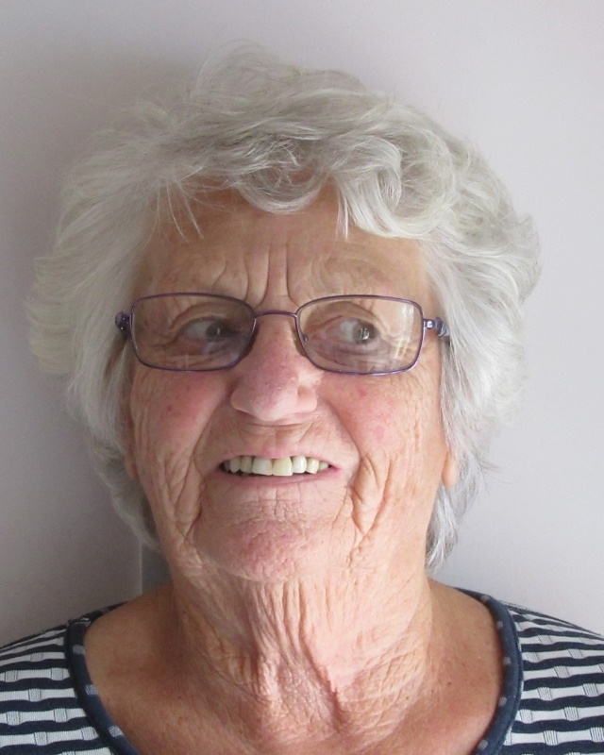

Application for Employment

Application for Employment

CONFIDENTIAL WHEN COMPLETED

Please complete this form by typing, do not hand write. Return by email to info@vasws.org.uk or post to the address at the bottom of the form.

We wish to ensure that comparison between applicants is fair and in line with our Equal Opportunities Policies. The information you provide on this form is the only information we will use in deciding whether you will be shortlisted for an interview. It is therefore essential that you complete the form fully and that you clearly demonstrate how you meet each point on the person specification within the context of the job description for the role you are applying for. Please note that CVs are not accepted and will not be read.

Position applied for

Contact details

Full Name
Address
Postcode
Phone number
Email address

When would you be available to take up the post?

References

Please give below the name and address of two referees who can comment on your suitability for the post. These should not include relatives or purely personal friends. If you have been employed, we would normally seek a reference from your present or most recent employer.

Referee one:

Name

Company

Email

Phone number

Referee two:

Name

Company

Email

Phone number

We will not contact your referees unless we offer you the post.

Education

Please give details of your education plus qualifications gained. Please note we require proof of all qualifications listed in your application form.

School/college/ university | Qualifications | Start date | End date

Other Training

Please give details of any other relevant training. Please note we require proof of all training listed in your application form.

Description of training | Start date | End date

Employment history

Please put in date order, starting with the most recent.

Employer or Organisation | Role | Start date | End date

Supporting information

Please tell us why you are applying for this role:
Max 500 words

In the following section we would like you to give specific information in support of your application. Please demonstrate how you have the necessary skills and abilities.

Experience of working in health and social care

Experience of working in community settings

An understanding of the issues faced by people who will be using the social prescription service

Experience of working with volunteers in a supervisory role
Knowledge of adult safeguarding issues

An understanding of the effects of loneliness and its effect on health and well-being
Proven experience of planning, prioritising, carrying out and recording work with minimal supervision

Experience of working using IT packages: Word, Outlook, Excel and PowerPoint

Ability to work effectively in partnership with others

Ability to take a flexible, facilitative and creative approach

Accessibility and Right to Work
Do you consider yourself to have a disability? YES/NO
Please tell us if there are any ‘reasonable adjustments’ we can make to assist you in your application or with our recruitment process

Do you need a work permit to work in the UK? YES/NO

Data Protection Act 2018

As part of the recruitment procedure, we collect and store sensitive personal data about you. It is our policy to store data relating to recruitment procedures for twelve months after the date on which it is submitted, for internal auditing purposes. Any information of this nature will be treated confidentially.

Sensitive personal data is defined as information relating to any of the following: racial or ethnic origin, political opinions, religious beliefs, trade union membership, health, sexuality or sex life, offences and/or convictions.

For the purposes of the Act the Data Controller is Voluntary Action South West Surrey.

I confirm that to the best of my knowledge the information I have provided on this form is correct and I accept that providing deliberately false information could result in my dismissal.

Name __________________________ Date ________________

Return this application form by email to info@vasws.org.uk

